The Three Body Universe: What Investors Can Learn from Surviving an Alien Invasion

The Nature of Financial Markets

Cixin Liu’s novel Ball Lightning starts at When Chen’s 14th birthday party at his small home during a violent lightning storm in late 20th century China:

. . .
“Ah, life,” Dad said, and downed his drink. Then, staring intently at the cluster of candle flames, he said, “Life is so random, all probability and chance. Like a twig floating in a brook, caught on a stone or seized by an eddy—”
“He’s too young. He doesn’t understand this stuff,” Mom said.
“He’s not young!” said Dad. “He’s old enough to learn the truth about life!”
“And you know all about that,” Mom said, with a sarcastic laugh.
“I know. Of course I know!” Dad poured another glass and drank half, then turned to me. “Actually, son, it’s not hard to live a wonderful life. Listen to me. Choose a tough, world-class problem, one that requires only a sheet of paper and pencil, like Goldbach’s Conjecture or Fermat’s Last Theorem, or a question in pure natural philosophy that doesn’t need pencil and paper at all, like the origin of the universe, and then throw yourself entirely into research. Think only of planting, not reaping, and as you concentrate, an entire lifetime will pass before you know it….
Outside lightning flashed dramatically.
This time, though, the arc came in through the wall, emerging like a spirit from an oil painting of a carnival of the Greek gods. It was about the size of a basketball, and shone with a hazy red glow. It drifted gracefully over our heads, followed by a tail that gave off a dark red light. Its flight path was erratic, and its tail described a confusing complicated figure above us. It whistled as it floated, a deep tone pierced with a sharp high whine, calling to mind a spirit blowing a flute in some ancient wasteland.
Mom clutched fearfully to Dad with both hands, an action I have looked back on in anguish my entire life. If she had not done that, I might have one relative left alive today.
The thing continued to drift like it was looking for something. It finally stopped and found it, hanging about half a meter over my father’s head. Its whistle became deeper and intermittent, like bitter laughter.
I could see inside the translucent red blaze. It seemed infinitely deep, and a cluster of blue stars streamed out of the bottomless haze, like a star field seen by a spirit rocketing across space faster than the speed of light.
Later, I learned that the internal energy density of this mass could have reached twenty thousand to thirty thousand joules per cubic centimeter, compared to just two thousand joules

per cubic centimeter for TNT. But while its internal temperature might have exceeded ten thousand degrees, its surface would be cool.
My father lifted his hand, more to protect his head to try to touch the thing. Fully extended his arm seemed to exert an attractive force that pulled the thing toward it like a leaf’s stomata absorb a drop a dew.
With a blinding flash a deafening boom, the world around me exploded.
What I saw after the flash blindness lifted from my eyes would stay with me for the rest of my life. It was like someone had switched the world to grayscale mode in an image editor: instantaneously, the bodies of my mom and dad had turned black and white. Or, rather, gray and white, because the black was the result of shadows cast by lamplight playing off the creases and folds of their bodies. The color of marble. Dad’s hand was raised, and Mom clutched at his other arm with both hands. There still seemed to be life in the two pairs of eyes and stared petrified out of the faces of these statues.
A strange odor was in the air, which I later learned was the smell of ozone.
. . .

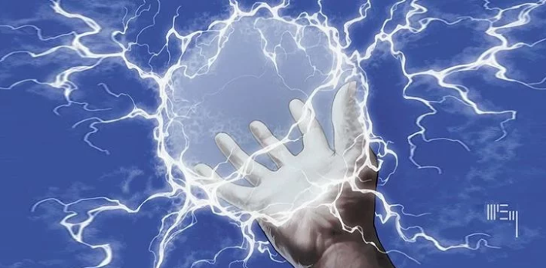

Years later, When Chen is working as civilian scientist helping China to weaponize ball lightning when Ding Yi, a brilliant but mad scientist, explains what the mysterious ball lightning really is:

. . .
Colonel Xu said, “Now you all must be brimming with the anticipation for Professor Ding to tell us just what ball lightning is.”
Ding Yi nodded. “I know that lots of people have poured immense effort into unlocking the secret of nature, including the likes of Dr. Chen and Major Lin. They devoted their life’s energies to taking the EM (electro magnetics) and fluid equations and twisting them to mind-shattering degrees, until they nearly broke. Then they put in one patch after another to plug the holes, adding extra struts to support the teetering edifice, ultimately coming up with something far too huge and complicated, and incomparably ugly. . . .Dr. Chen, do you know where you failed? It wasn’t that you weren’t complex enough. It was that you didn’t think simply.”
It was the same thing I’d heard from Lin Yun’s father. Two uncommon men in two different fields had come up with the same profound observation.
“How simple could it be?” I asked, mystified.
Ding Yi disregarded my question and went on: “Next, I will tell you what ball lightning is.”
At this moment, the few scattered stars that had begun to appear in the heavens seemed to stop their twinkling, as if listening to God’s last judgement.
“It is nothing more than an….”
. . .

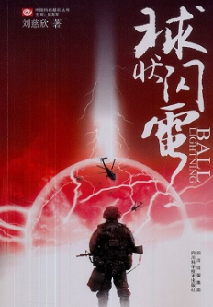

After the Chinese Government learns how to weaponize ball lightning, it is used to thwart a terrorist attack. In the process, however, a group of school children is killed leaving When Chen disheartened and driftless. One night, he is awakened by a laptop he used for research at the ball lightening test facility. However, the processor and memory had been destroyed by the ball lightening weapon.

. . .
So I picked up the phone and dialed Ding Yi’s cell phone in a fluster. He was evidently not asleep, since the phone only range once before he answered.
“Come to my place at once! The faster the better! It . . . it’s turned on. It’s running. I mean, the . . . the notebook computer is running. . . .” I found it hard to be coherent, given the circumstances.
“Is this Chen? I’ll be right over. Don’t touch anything until I get there,” Ding Yi said in a voice that sounded perfectly calm.
After I set down the telephone, I looked back at the laptop. As before, it was quietly displaying the desktop, as if waiting for something. The desktop’s blue-green odd-eyed stare left me unable to remain in the room, so without even getting dressed, I went outside. The hall of the bachelors’ apartments was quiet enough to hear the snoring of my neighbor, and I felt much better and breathed more easily. I stood in the doorway and waited for Ding Yi to get there.
He arrived quickly. Ball lightning theoretical research was to be transferred to the Institute of Physics, so he had been in the city for the past few days in connection with that.
“Shall we go in?” he said, after a glance at the tightly closed door behind me.
“I . . . I won’t. You go in,” I said, turning aside to let him pass.
“It might be something incredibly simple.”
“Maybe for you. But me . . . I can’t take it anymore,” I said, pulling at my hair.
“I don’t know whether or not supernatural phenomena exist, but what you’ve seen is certainly not that.”
His words calmed me down a bit, like an adult’s hand grabbed by a child in the terrifying dark, or the firm ground beneath a drowning man’s feet. But this feeling immediately made me depressed. Before Ding Yi, my mind was weak; before Lin Yun, my actions were weak. I was such a fucking weakling—no wonder I placed after Ding Yi and Jiang Xingchen in Lin Yun’s heart. Ball lightning had molded me into this form; from that night of terror in my youth, the shape of my psyche had been determined. I was destined to live my whole life with a terror no one else could feel.
Biting the bullet, I followed Ding Yi into my room. Past his thin shoulder I saw that the computer on the table had entered screen saver mode, the star field. Then the screen went dark.
Ding Yi moved the mouse and the desktop came up again. I had to avert my eyes from the strange grass.
Ding Yi picked up the computer and, after inspecting it, passed it to me. “Take it apart.”

“No.” I pushed it aside. When I made contact with its warm case, my hand jerked back as if shocked. Something about it felt alive.
“Fine. I’ll take it apart. You look at the screen. And find a Phillips screwdriver.”
“You don’t need one. I didn’t put the screws back after the last time.”
And so he began feeling around the laptop. They were ordinarily hard to dismantle, but mine was late model modular Dell, so he was easily able to open the bottom of the case. As he worked, he said, “Do you remember the first time we used the high-speed camera to record the ball lightning’s energy discharge? We played it back frame by frame, and when we reached the point where the incinerated wooden cube was a transparent outline, we paused the image. Do you remember what Lin Yun said then?”
“She shouted: ‘It’s like a cubic bubble!’”
“That’s right. . . . Pay attention to the screen as I look inside,” he said, then bent at the waist and peered into the interior of the open computer.
At that moment, the scree went black, except for two lines displaying a self-check error message, indicating that no CPU or memory had been found.
Ding Yi flipped over the computer to show me the motherboard, where the CPU and RAM were empty.
“The moment I observed this, the quantum wave function collapsed.” He set the computer carefully down on the table. Its screen remained black.
“Do you mean that the incinerated CPU and memory sticks exist in a quantum state, just like the macro-electrons?”
“Yes. In other words, when the chips experience matter-wave resonance with the macro-electron, they turn into a macro-particle in a quantum state. Ball lightning’s energy release is essentially the full or partial superposition of the probability clouds of it and its target. The chips’ state is indeterminate—they exist between two states, destroyed and undestroyed. Just now, when the computer started up, they were in the latter state, the CPU and memory completely unharmed and plugged into their slots in the motherboard. But when I observed them, their quantum states collapsed back into a destroyed state.”
“In the absence of the observer, when will the chips exist in an undestroyed state?”
“That’s undetermined. They only exist as the probability of an event. You can consider the chips in this computer to be within the probability cloud.”
“Then the animals that were burned up—are in a quantum state, too?” I asked nervously, with the premonition that I was nearing an unbelievable truth.
Ding Yi nodded.
I didn’t have the courage to ask my next question, but Ding Yi looked calmly at me, and clearly knew what I was thinking.
“Yes, the people too. All the people who have been killed by ball lightning exist in a quantum state. Strictly speaking, they haven’t really died. They’re like Schrodinger’s cat, and

exist indeterminately in two states, living and dead.” Ding Yi stood up and walked to the window and looked out at the deep night. “To them, to be or not to be is indeed a question.”
“Can we see them?”
Ding Yi waved a hand at the window, as if resolutely dismissing the idea from my brain. “Impossible. We’ll never be able to see them, since their collapsed state is death. They exist alive for certain probability of the quantum state, but when we appear as observers, they immediately collapse to a destroyed state, to their urns or graves.”
“Do you mean they’re alive in some parallel universe?”
“No, no. You’ve misunderstood. They live in our world. Their probability cloud might cover quite a large area. Perhaps they’re even standing in this room, right behind you.”
The skin crawled on my back.
Ding Yi turned around and pointed at me. “But when you turn around to take a look, they immediately collapse to a destroyed state. Trust me: neither you nor any person will ever be able to see them. That includes cameras and other observers. Detection of their presence is impossible.”
“Can they leave traces behind in the real world that are not in a quantum state?”
“They can. I suspect you’ve already seen such traces.”
“Then why don’t they write me a letter!” I shouted, losing control. By “they,” I meant only two people.
“Compared to an object like a computer chip, a conscious being in a quantum state, particularly a human, behaves in a far more complicated manner. How they interact with us in the non-quantum-state world is an unanswered mystery, one that contains many logical and even philosophical traps….”
. . .

Like When Chen’s father states, life is all probability and chance and the same can be said of financial markets. And like Professor Ding Yi points out later, conscious beings behave in a very complicated manner—think of all the extreme political/economic developments and technological breakthroughs—which makes trying to determine the probabilities of financial markets that much more difficult.

Can an investor sensibly and confidently assign probabilities in an uncertain world? And secondly, in order to generate better than average returns, can an investor sensibly and confidently assign probabilities that differ from the average market participant?

Are investors destined to live like When Chen in terror of the unknown? How do you confidently deploy capital in a world with many logical and even philosophical traps? Or is it possible for investors to simplify the problem and have the confidence of Ding Yi?

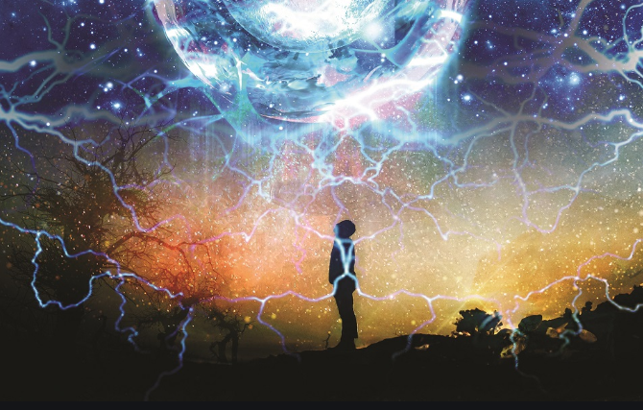

Fairlight Capital: Competitive Strategy

In Cixin Liu’s second book of the Remembrance of Earth’s Past trilogy, The Dark Forest, Zhang Beihai, a political officer in the newly created Chinese Space Force, explains to fellow officers that the greatest threat facing the space force and humanity as they await the arrival of the invading Trisolaran Fleet in 400 years is not the enemy but rather a weak human spirit.

. . .
General Change Weisi nodded again. “I agree. Defeatism is our greatest enemy at present. The military commission is acutely aware of this. It’s why political and ideological work in the services will be critical. Once the basic units of the space force are in place, the work will become more complex.”
Zhang Beihai flipped open his notebook. “The work report follows,” he said, and began to read: “Since the establishment of the space force, our primary focus in political and ideological work among the troops has been to conduct a survey of the overall ideological status of officers and soldiers. Since the organization of this new branch is simple at the present time, with few members and few administrative levels, the survey was conducted through informal meetings and personal interaction, and a corresponding forum was set up on the internet. The results of the survey are worrying. Defeatist thinking is prevalent and spreading swiftly among the troops. The mentality of a sizeable proportion of our comrades consists of terror toward the enemy and a lack of confidence in the future of war.
“The source of this defeatism stems primarily from the worship of technology, and the underestimation or complete dismissal of the role of human initiative and the human spirit in war. It is a development and extension of techno-triumphalism and the ‘weapons decide everything’ theory that has cropped up in the armed forces in recent years. The trend is particularly pronounced among highly educated officers. Defeatism among the troops takes the following forms:
“One. Treating one’s duty in the space force as an ordinary job: despite working with dedication and responsibility, lacking enthusiasm and a sense of mission, and doubting the ultimate significance of one’s work.
“Two. Passive waiting: believing that the outcome of the war depends on scientists and engineers; believing that prior to breakthroughs in basic research and key technologies, the space force is just a pipe dream, and subsequent confusion about the importance of its present work; being satisfied simply with completing tasks related to establishing this military branch, lacking innovation.
“Three. Harboring unrealistic fantasies: requesting to use hibernation technology to leap four centuries into the future and take part in the Doomsday Battle directly. A number of younger comrades have already expressed this wish, and one has even submitted a formal application. On the surface, this is a positive state of mind, a desire to throw oneself onto the front lines, but it is essentially just another form of defeatism. Lacking confidence in victory and

doubting the significance of our present work, a soldier’s dignity becomes the only pillar sustaining work and life.
‘Four. The opposite of the above: doubts about the dignity of the soldier, the belief that the military’s traditional moral code is no longer suitable for the battlefield, and that fighting to the end has no meaning; the belief that a soldier’s dignity only exists when there is someone to see it, and when a battle ends in defeat and no humans are left in the universe, then this dignity loses significance. Although only a minority hold this notion, the abrogation of the very worth of the space force is exceedingly harmful.”
. . .

Like the soldier’s in the Chinese Space Force, how does an investor keep faith that his hard work will lead to better than average results? How does an investor believe that his innovation and work are of importance and not cancelled by market forces? How does an investor realistically evaluate his strengths against millions of other market participants? How does an investor sustain dignity in the face of advancing technologies?

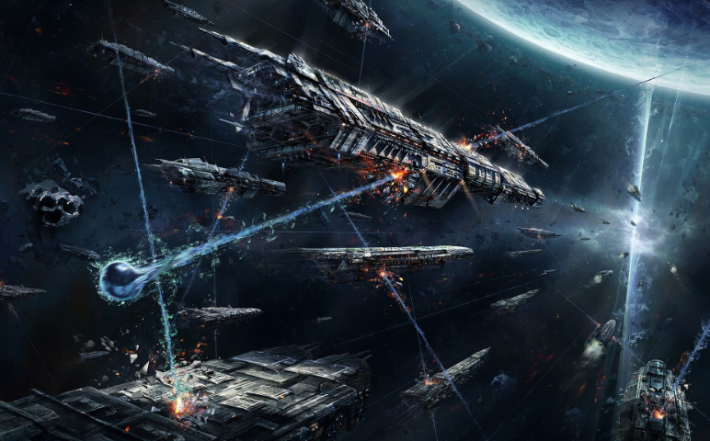

. . .

Over the next couple hundred years, while all human society moved from total hopelessness to unwarranted optimism and back to complete despair, the Trisolarans—who had the capability to spy on all of humanity and communicate with extremist humans through super advanced microcomputers—persistently continued to focus their efforts on eliminating a unassuming loner named Lou Ji.

Unlike humans, Trisolarans knew their biggest threat came from ingenuity and strategy. They knew that technology doesn’t guarantee success. At the end of the The Black Forest, three sophons, proton sized supercomputers, unfolded from higher dimensional space to three-dimension spheres with time so they could project communications from Trisolarans to the Wallfacer, Lou Ji.

. . .
Lou Ji smiled and shook his head. “No. I’m not a savior. I just want to leave here like an ordinary person and go home. I will rest for a bit and be on my way.”

Two of the three spheres disappeared. The text on the one that remained which no longer glowed, now seemed dim and dreary.

In the end, strategy is where we failed.
. . .

Like Lou Ji’s defeat of the Trisolaran invasion, we aim to have a better strategy than the market, and thus significantly increase the odds of superior returns while minimizing risk of permanently losing our capital. We aim to accomplish this by using Ding Yi’s wisdom to simplify the problem:

- One, being small is very important. As it happens, when market capitalization shrinks, volatility increases and valuations along with liquidity decrease. Volatility is a double-edged sword. Names that are volatile can cause great pain, but they also give you the opportunity to buy at much cheaper prices or sell at much higher prices.
- Two, insulating ourselves from outside influences by making our own decisions and not letting the crowd influence our decision making. If we can’t stick to our investment process and abide by our rules, we will likely underperform or at best be average.
- Three, structuring our lives so you don’t need to do anything you don’t want to do. Opportunities will come, we just not to be content waiting. As it happens being smart is not very important. Yes, you need a minimum number of IQ points but after 130 or 140, you are no better off as an investment manager. Your incentives matter much more than your IQ points. Most investment errors are not analytical but rather emotional.
- Four, surviving looking stupid. To generate outsized returns, you must zig when the market says zag. When the investment goes wrong you will look dumb.
- Five, be willing to concentrate in a few investments. The amount of opportunities that are understandable and offer superior returns is usually very limited, and unlikely to be more than 10 at any given point in time—except during large market dislocations.
- Six, limiting leverage. If a portfolio declines 25% to 50%, it needs to deliver 33% to 100% returns just to breakeven. Limiting downside risks is key to long-term outperformance.
- Seven, keeping it simple stupid and let compound interest and time work their magic. Impatience can cause you to do stupid things and makes it hard to sit still. Who doesn’t want to own the next unicorn disruptor or drug that cures cancer? However, the odds of being successful in these types of ventures are much lower than investing in businesses that have more predictable cash flows and lower valuations. If you stick to your investment process and don’t violate your rules (valuation limitations—e.g. 15% earnings yield—strong balance sheet, etc.), time will take care of everything else. For an investment manager, it is important to be content no matter what level of income he or she generates in any given year—even if it is zero or less than zero.
- Eight, having patience and a little bit of luck. In investing, business and life, random events have much to do with the pace of success. The best you can do is put the odds in your favor, set up your life so you can be patient and reduce the number of dumb decisions to a minimum (this is tough).

In Death’s End, the third book in the Remembrance of Earth’s Past trilogy, two human survivors must choose to either live comfortably in their own mini-universe or reenter the great universe. If they choose to live comfortably, the universe—along with all other living beings—will very likely die out at some point in the distant future. If, however, they reenter the universe, they will be subject to the uncertainties and vicissitudes that characterize life, but they will increase the odds that life will flourish indefinitely.

. . .
Through Universe 647’s control system, Sophon (an AI robot) managed to move the mini-universes exit inside the great universe. The door moved quickly through the great universe, searching for a habitable world. The amount of information that the door could transmit to the mini-universe was very limited, and no images or videos were possible. All that could be sent back was a rough analysis of the environment. This was a number between negative ten and ten, indicating the habitability of the environment. Humans could survive only if the number were greater than zero.
The door jumped tens of thousands of times in the great universe. After three months, only once did they discover a habitable planet, with a rating of three. Sophon had to concede that this was probably the best result they could get.
“A rating of three indicates a dangerous and inhospitable world,” Sophon warned.
“We’re not afraid,” Said a resolute Cheng Xin. Yifan nodded. “Let’s go there.”
. . .

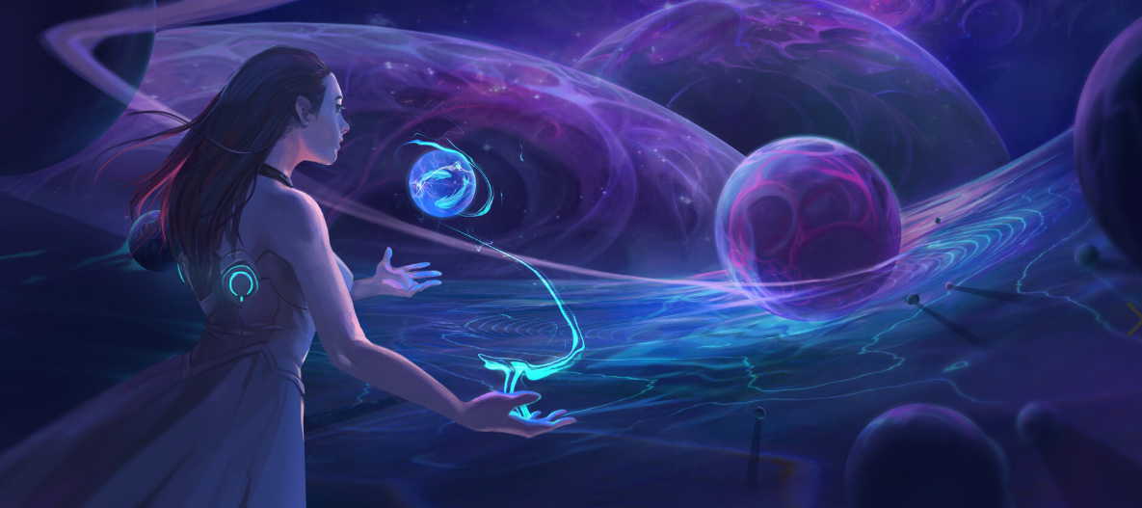

https://en.wikipedia.org/wiki/Ball_Lightning_(novel)
https://www.theworldofchinese.com/2019/02/lightning-round/
https://danwang.co/liu-cixins-three-body/
https://www.pinterest.com/pin/276901077079383014/
https://www.artstation.com/artwork/VdvYOn

